Wayne Mitchell
CIS. 250
Case Study 2
- A Data process symbol is used to represent a process like a black box you add something in a bunch of stuff happens inside and then it spits out data that the data flow arrow passes to the data store where it sits until its needed by an entity which are external representations that input or take data out of the system.
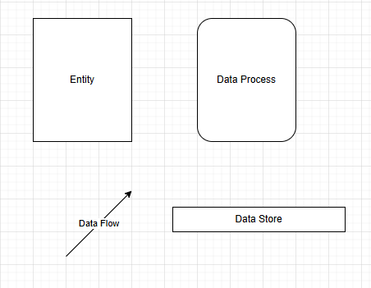
- 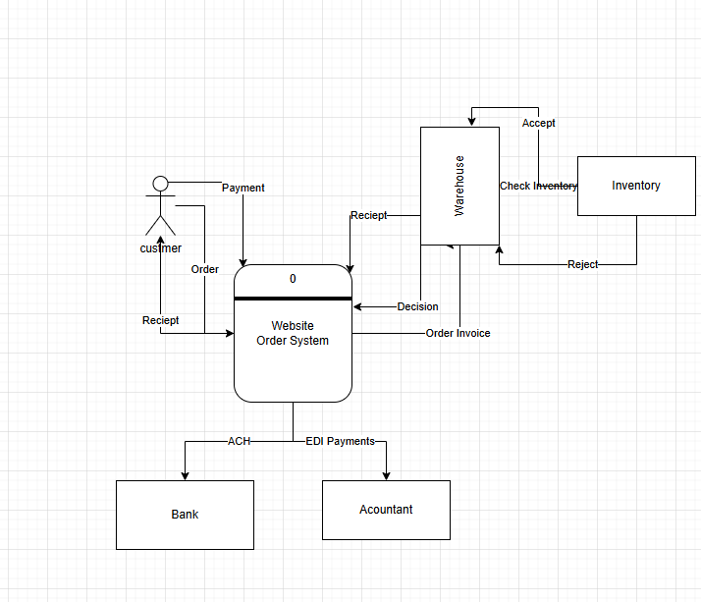
3. 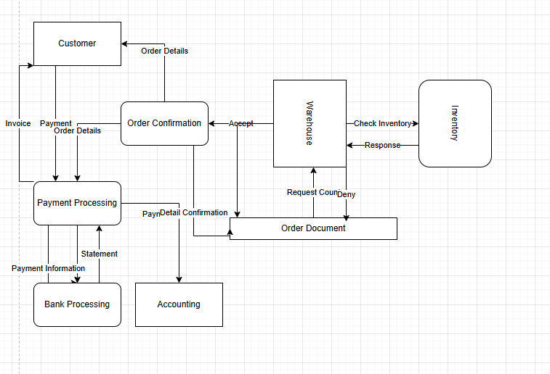
4. Leveling is important because it allows you to see the entire process for any given task all the way down to its primitive functions if needed to be inspected or looked at how those functions work on a fundamental level while balancing is important to keep information consistent among your diagrams which keeps confusion to a minimum and improve on overall readability because you wont have to search for hidden factors or methods in a diagram.

